AIM:- To perform Library Database.

**Book (bid, title, pub_year, pub_name)**

**Author (bid, auth_name)**

**Publisher (pub_name, address,ph_no)**

**Book Copies (bid, branchid, no_of_copies)**

**Book_lending (bid, branchid, card_no, date_out, due_date)**

**Lib_branch (branchid, branch_name, address)**

**Card (card_no)**

DATABASE CREATION



PUBLISHER TABLE CREATION

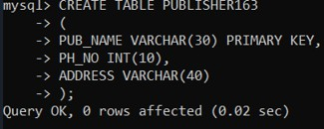

VALUES INSERTION IN PUBLISHER TABLE

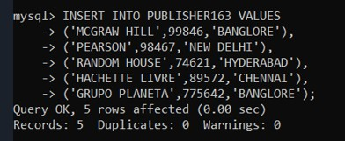

PUBLISHER TABLE DISPLAY

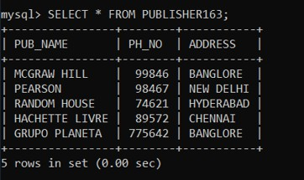

DESCRIPTION OF PUBLISHER TABLE

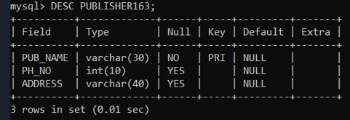

**BOOK TABLE CREATION:**

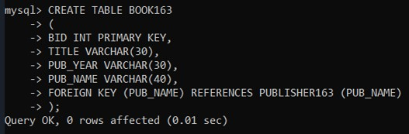

VALUES INSERTION IN BOOK TABLE

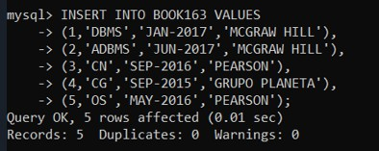

DISPLAY BOOK TABLE

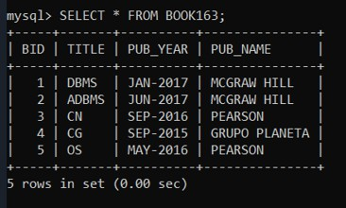

BOOK TABLE DESCRIPTION

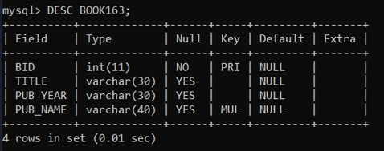

AUTHOR TABLE CREATION

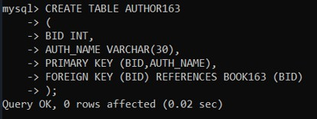

VALUES INSERTION IN AUTHOR TABLE

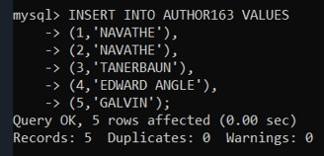

DISPLAY AUTHOR TABLE

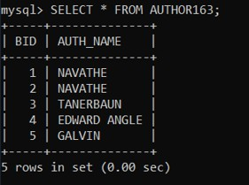

**AUTHOR TABLE DESCRIPTION**

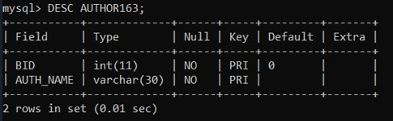

LIBRARY BRANCH TABLE CREATION:

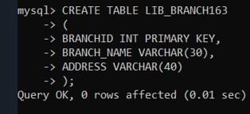

VALUES INSERTION IN LIB_BRANCH TABLE

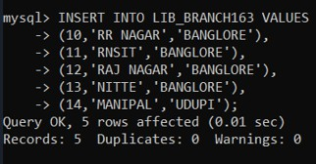

DISPLAY LIBRARY BRANCH TABLE

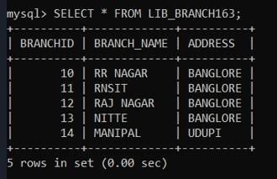

**LIBRARY BRANCH TABLE DESCRIPTION**

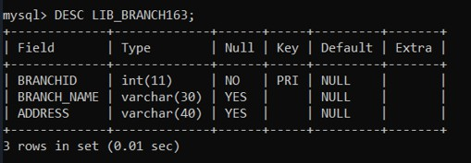

CARD TABLE CREATION:

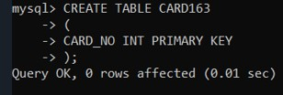

VALUES INSERTION IN CARD TABLE:

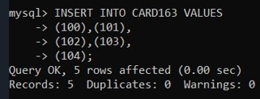

DISPLAY CARD TABLE

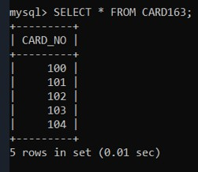

**DESCRIE CARD TABLE**

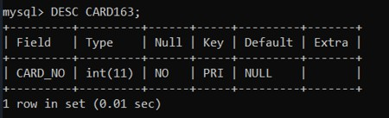

BOOK COPIES TABLE CREATION:

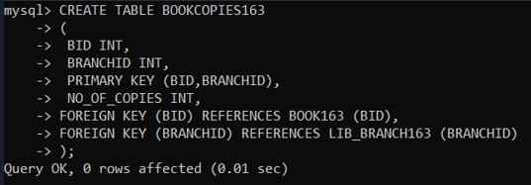

VALUES INSERTION IN BOOK COPIES TABLE

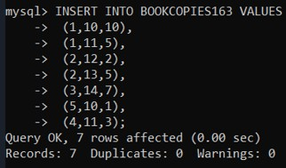

DISPLAY BOOK COPIES TABLE

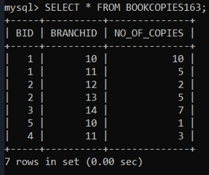

**DESCRIBE BOOK COPIES TABLE**

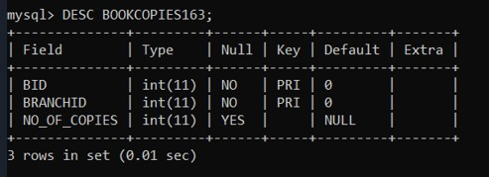

BOOK LENDING TABLE CREATION:

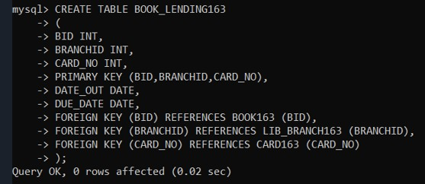

VALUES INSERTION IN BOOK LENDING TABLE

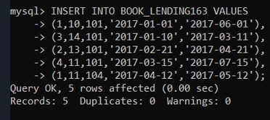

DISPLAY BOOK LENDING TABLE

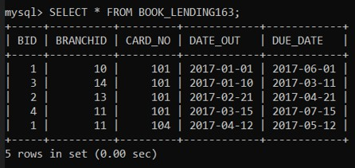

DESCRIBE BOOK LENDING TABLE

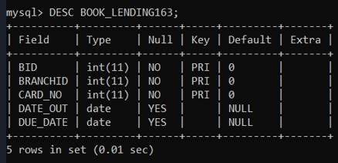

**AIM:-To perform all the Queries of the library database.**

1. 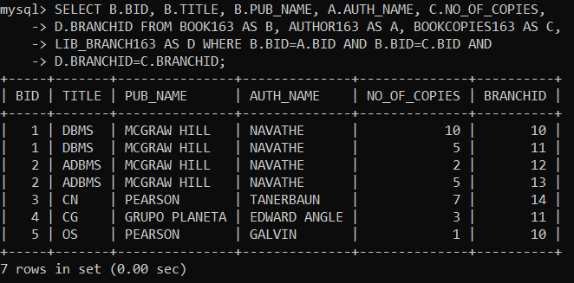**Retrieve details of all books in the library - id,title,name of publisher, author, number of copies in each branch, etc.**
2. 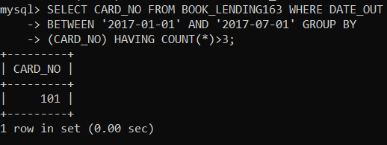**Get the partition of borrowers who have borrowed more than 3 books, but from Jan 2017 to Jun 2017.**
3. **Delete a book in the BOOK table. Update the contents of other tables to reflect this data manipulation operation.**

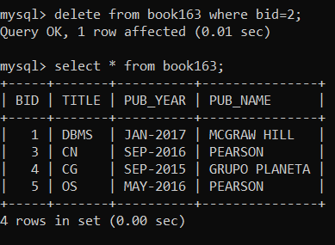

1. 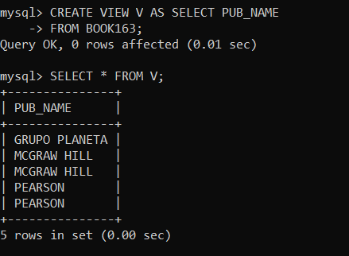**Partition the BOOK table based on year of publication. Demonstrate its working with a simple query.**
2. **Create a view of all books and its number of copies that are currently available in the Library.**

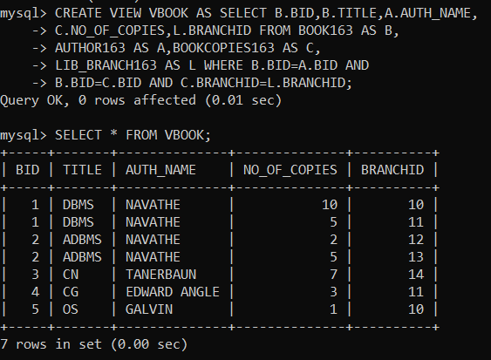

1. **Find the date out and due date of the book lending.**

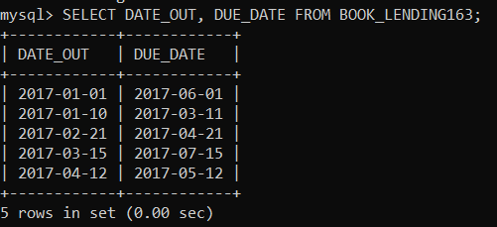

1. **Find the unique names of the Author.**

